Length:
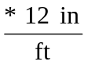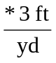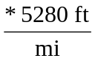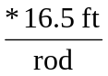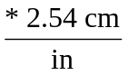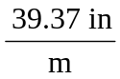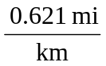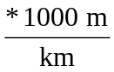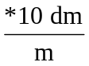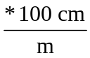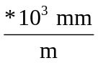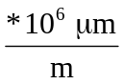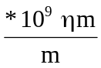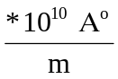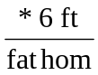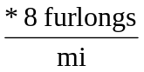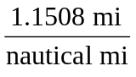

Mass/weight:
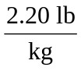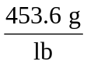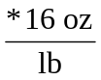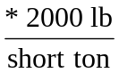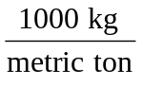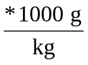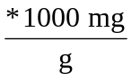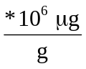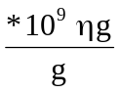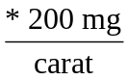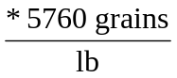

Volume:
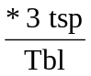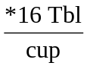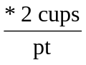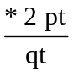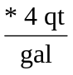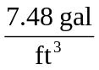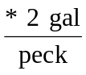
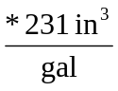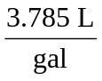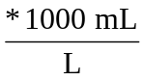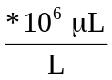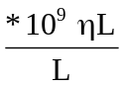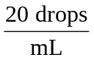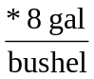

Time:
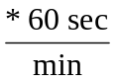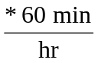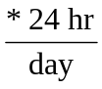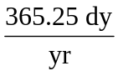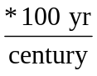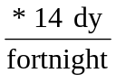

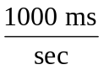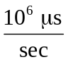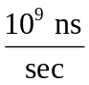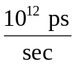
Miscellaneous:
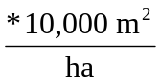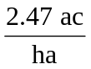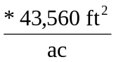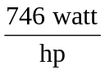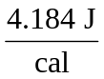
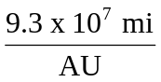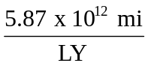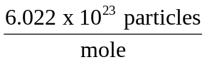

*1 atm = 14.7 lb/in² = 101.3 kPa = 29.92 inHg = *760 mmHg = *760 Torr

